Match the photo and the invention/innovation to the correct name.

1. 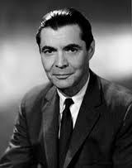 Electron microscopy; first description of ribosomes of the endoplasmic reticulum
2. Emil Racoviţă
3. George Emil Palade
4. Constantin Parhon
5. Gheorghe Marinescu

Answer: b

1. 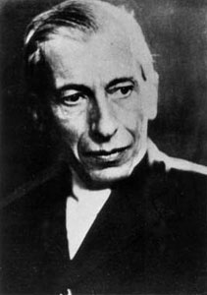 Insulin
2. Constantin Parhon
3. Nicolae Paulescu
4. Victor Babeş
5. Grigore Antipa

Answer: b

1. 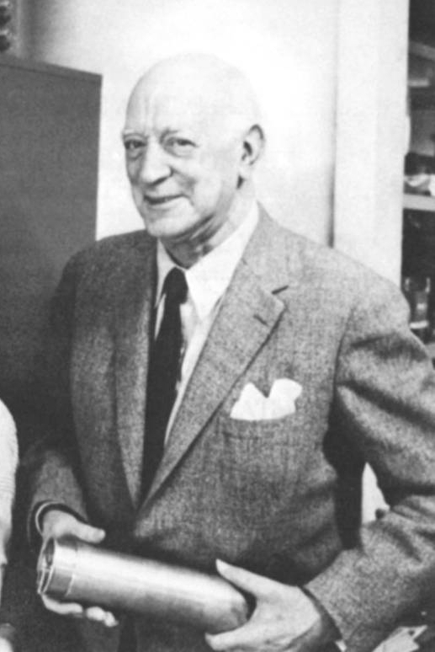 One of the world’s first jet plane’s; the Coandă effect of fluid dynamics.
2. Traian Vuia
3. Henri Coanda
4. Aurel Vlaicu
5. Dumitru Prunariu

Answer: b

1. 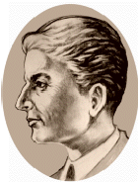Amphetamine
2. Costin Neniţescu
3. Henrick Kacser
4. Nicolae Teclu
5. Lazăr Edeleanu

Answer: d

1. 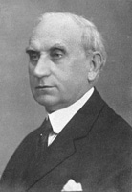 Early founder of forensic medicine
2. Aurel Babeş
3. Constantin Parhon
4. Victor Babeş
5. Mina Minovici

Answer: d